Automatic of Sales Contracts – CRIM 0335

|  |  |  |  |  |
| --- | --- | --- | --- | --- |
| **Ver** | **Date** | **Author** | **Comments** | **Reviewed by** |
| 1 | 26/11/2020 | Tom Bell | CRIM 0335 | TBC |
|  |  |  |  |  |

Requirements 2

Prerequisites 2

Solution Overview 2

Solution Details 2

Security 3

Companies 3

Data Migration 3

Test Steps 3

Technical Implementation 3

Requirements

The system must automatically close Sales Contracts when it has been marked as Retention Released. If a Sales Contract is not using Retention Payments it must automatically close when the final invoice has been received. Any errors in closing must be logged in a lobby tile/ saved search.

Prerequisites

<Describe any pre-requisites that this development may rely upon, data configuration or other developments>

Solution Overview

The system will automatically close the Sales Contract when the “Release Final Retention” check box has been checked. If the Sales Contract is not using Retention Payments, it will automatically close after the final invoice has been received.

No preference for this be ran as a batch job overnight or instantly.

Any errors will be logged the Sales Contract Analysis screen. Visible through a saved search.

**Logic Overview:**

**Case 1 – Sales Contract using Retention Payments**

If Sales Contract “Release Final Retention” is field is checked then close Sales Contract.

**Case 2 – Sales Contract not using Retention Payments**

If Sales Contract “Total Retention” is = 0 and Sales Contract has been fully invoiced then close Sales Contract.

Solution Details

Automatic closure based on Retention

When the “Release for Final Retention” field has been checked on the Application for Payment for a Sales Contract the system must automatically close the Sales Contract.

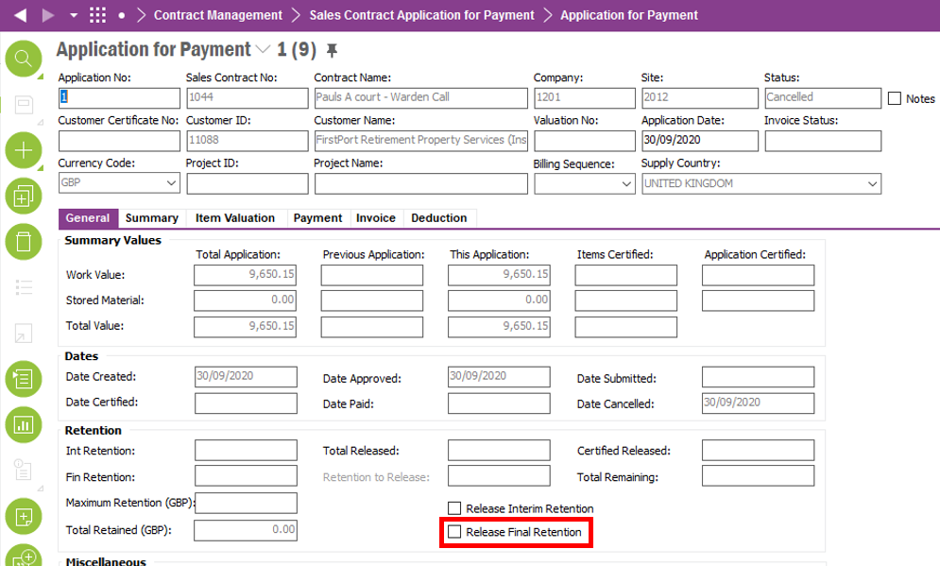

Closure based upon Receiving Final Invoice

If a Sales Contract is not using Retention payments, the system must automatically close a Sales Contract when the final invoice has been received.

The system must automatically close the Sales Contract when the Final Invoice for the sales order has been received.

The below screenshot shows the Sales Contract screen, highlighted is the Total Retention field. If this field is 0, then Retention payments are not being used. These Sales Contracts must close when the Sales Contract’s Final Invoice has been received.

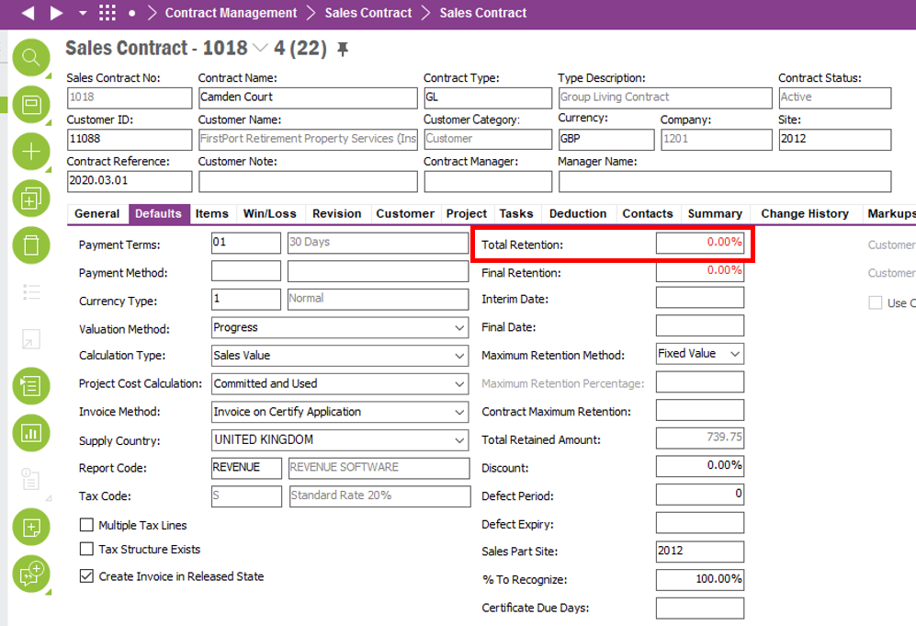

Technical.

Field Definitions.

<New Field/CLU Definition>

|  |  |  |  |  |  |  |
| --- | --- | --- | --- | --- | --- | --- |
| New DB Object Name | DB Object Item/Field Names | Item Description | Item Data Type | Item Syntax | Calculation Spec, if Derived | LOVs/Enums/Is Mandatory? |
|  |  |  |  |  |  |  |
|  |  |  |  |  |  |  |
|  |  |  |  |  |  |  |
|  |  |  |  |  |  |  |
|  |  |  |  |  |  |  |
|  |  |  |  |  |  |  |
|  |  |  |  |  |  |  |
|  |  |  |  |  |  |  |
|  |  |  |  |  |  |  |
|  |  |  |  |  |  |  |
|  |  |  |  |  |  |  |
|  |  |  |  |  |  |  |

Security

<Define security controls> (Who needs access to this and will it be restricted from any other users etc)

Companies

Applies to the following companies. All.

|  |  |
| --- | --- |
| **Company** | **Required (Y/N)** |
| 1201 | Y |
| TBC |  |
|  |  |

Data Migration

<Describe any data migration impacts this development may have – i.e additional data to be migrated>

Test Steps

<Steps that needs to be taken to test this change. Please provide expected results> Updated post solution.

|  |  |  |
| --- | --- | --- |
| **No** | **Script\Test Steps** | **Expected Result** |
| 1 | When the check box “Release Final Retention Payment” is checked | The system will automatically close the sales contract. |
| 2 | When the final invoice for a sales contract has been received and that sales contract is not using retention payments. | The Sales Contract will automatically close when final invoice is received. |

Technical Implementation

<Completed by the technical developer - Technical solution, list packages, functions, Custom menus created etc >

Delivery Notes

* Database task name: Sales Contract Auto Closure
* Method for database task: C_EA_Customization_Util_API.Sales_Contract_Auto_Closure()
* Schedule name: Sales Contract Auto Closure
* Scheduled to run daily at 12:00 AM
* 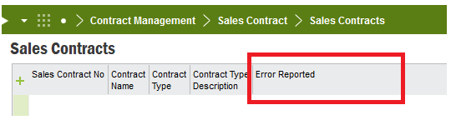Custom field ‘**Error Reported’** added to **Contract Management 🡪 Sales Contract 🡪 Sales Contracts** screen to log any errors recorded on the Sales Contract during the scheduled job.
* Import ACP for C0335 (ACP Finance) and publish to add the custom field ‘Error Reported’
* Please make sure to add the **Error Reported** column using **Column Chooser** if the column is not visible on the screen.
* All the IFS standard validations performed in manual process of Sales Contract closure are applied on automatic Sales Contract closure.
* IFS standard validations are as follows.

1. Sales Contract must be in ‘Completed’ status for it to get closed.

Error reported: **‘Sales Order must be in Completed status.’**

1. Is there any Application for Payments not in **Fully Paid or Cancelled** statuses for the Sales contract?

Error reported: **‘There are application for payments not in Fully Paid or Cancelled statuses.’**

1. Does the retention is released fully in application for payments?

Error reported: **‘The retention is not released fully in application for payments.’**

1. The total paid amount on all applications must be equal to (or higher) than the total contract sales value.

Error reported: **‘The total paid amount on all applications must be equal to (or higher) than the total contract sales value.’**